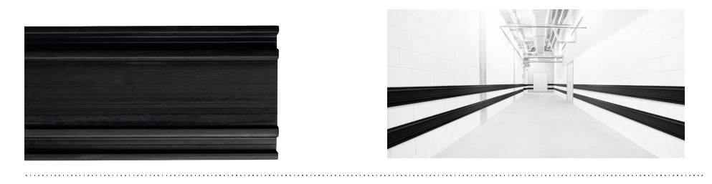


SPECIFICATION

ELASTO’PUNCH 200E
WALL PROTECTION RAIL – 200 MM HIGH
- Description: E-shaped flat protection rail in non-rigid and smooth thermoplastic elastomer (Elasto’Punch 200E as manufactured by SPM) comprising a 200 mm height profile, 15 to 30 mm thick, solid colour, giving it excellent impact-resistance properties and good ageing and UV resistance.
- Environment: no heavy metals are used in its formulation, nor PBT/BPA. 100% of the product are recyclable.
- Colour: black.
- Installation method: by screwing.

